**符昕宇 202364810311**

**To access my code more easily, you can find them at my github repository:**

**https://github.com/Fluorine-Brian/Code-for-Digital-Image-Processing**

**Homework1: Implement Figure 6.29 by programming with Python**

**Python Code:**

**import** numpy as np

**import** imageio.v2 as imageio

**import** matplotlib.pyplot as plt

**import** os

**import** matplotlib.gridspec as gridspec

**def** adjust_intensity_rgb(image, k):

    img_float **=** image.astype(float) **/** 255.0

    processed **=** img_float **\*** k

    processed **=** np.clip(processed, 0, 1)

**return** (processed **\*** 255).astype(np.uint8)

**def** plot_mapping_function(ax, slope**=**None, intercept**=**None, label_text**=**"", k_val=0.7, subplot_label=""):

    x **=** np.linspace(0, 1, 100)

**if** slope **is** **not** None **and** intercept **is** **not** None:

        y **=** slope **\*** x **+** intercept

**elif** slope **is** **not** None:

        y **=** slope **\*** x

**else**:

        y **=** x

    y **=** np.clip(y, 0, 1)

    ax.plot(x, y, 'b-', linewidth**=**2)

    ax.set_xlim(0, 1)

    ax.set_ylim(0, 1)

    ax.set_xticks(np.linspace(0, 1, 5))

    ax.set_yticks(np.linspace(0, 1, 5))

    ax.tick_params(axis**=**'both', which**=**'major', labelsize**=**10)

    ax.grid(True, linestyle**=**'-', alpha**=**0.8, color**=**'gray', which**=**'major')

    ax.set_aspect('equal')

**if** k_val **is** **not** None:

**if** "R,G,B" **in** label_text **or** label_text **==** "I":

            ax.plot([0, 1], [k_val, k_val], 'k--', alpha**=**0.3)

            ax.text(**-**0.1, k_val, r'$k$', va**=**'center', ha**=**'right', fontsize**=**12)

**elif** "C,M,Y" **in** label_text **and** intercept **is** **not** None **and** intercept > 0:

            val **=** 1 **-** k_val

            ax.plot([0, 1], [val, val], 'k--', alpha**=**0.3)

            ax.text(**-**0.1, val, r'$1-k$', va**=**'center', ha**=**'right', fontsize**=**12)

    ax.set_xticklabels([0, '', '', '', 1])

    ax.set_yticklabels([0, '', '', '', 1])

    ax.tick_params(axis**=**'y', pad**=**5)

    ax.text(0.95, 0.05, label_text, transform**=**ax.transAxes,

            ha**=**'right', va**=**'bottom', color**=**'white', backgroundcolor**=**'black', fontsize**=**9, fontweight**=**'bold')

    ax.text(**-**0.25, 1.1, subplot_label, transform**=**ax.transAxes,

            ha**=**'left', va**=**'top', fontsize**=**12, fontweight**=**'bold')

**def** plot_image_subplot(ax, image_data, subplot_label**=**""):

    ax.imshow(image_data)

    ax.axis('off')

    ax.text(**-**0.05, 1.05, subplot_label, transform**=**ax.transAxes,

            ha**=**'left', va**=**'top', fontsize**=**12, fontweight**=**'bold')

**if** __name__ **==** "__main__":

    input_dir **=** "original_image"

    output_dir **=** "output_image"

    os.makedirs(output_dir, exist_ok**=**True)

    image_filename **=** "Fig0630(01)(strawberries_fullcolor).tif"

    image_path **=** os.path.join(input_dir, image_filename)

    base_name **=** os.path.splitext(image_filename)[0]

    original_image **=** imageio.imread(image_path)

**if** len(original_image.shape) **==** 2:

        original_image **=** np.stack((original_image,) **\*** 3, axis**=-**1)

**elif** original_image.shape[2] **==** 4:

        original_image **=** original_image[:, :, :3]

    k **=** 0.7

    result_image **=** adjust_intensity_rgb(original_image, k)

    fig **=** plt.figure(figsize**=**(12, 8))

    gs **=** gridspec.GridSpec(2, 6, figure**=**fig, hspace**=**0.4, wspace**=**0.3, height_ratios**=**[2.5, 1])

    ax_img1 **=** fig.add_subplot(gs[0, 0:3])

    plot_image_subplot(ax_img1, original_image, subplot_label**=**"a")

    ax_img2 **=** fig.add_subplot(gs[0, 3:6])

    plot_image_subplot(ax_img2, result_image, subplot_label**=**"b")

    ax_f1 **=** fig.add_subplot(gs[1, 0])

    plot_mapping_function(ax_f1, slope**=**k, intercept**=**0, label_text**=**"R,G,B", k_val**=**k, subplot_label**=**"c")

    ax_f2 **=** fig.add_subplot(gs[1, 1])

    plot_mapping_function(ax_f2, slope**=**k, intercept**=**1 **-** k, label_text**=**"C,M,Y", k_val**=**k, subplot_label**=**"d")

    ax_f3 **=** fig.add_subplot(gs[1, 2])

    plot_mapping_function(ax_f3, slope**=**1, intercept**=**0, label_text**=**"K", k_val**=**k, subplot_label**=**"e")

    ax_f4 **=** fig.add_subplot(gs[1, 3])

    plot_mapping_function(ax_f4, slope**=**k, intercept**=**1 **-** k, label_text**=**"C,M,Y", k_val**=**k, subplot_label**=**"f")

    ax_f5 **=** fig.add_subplot(gs[1, 4])

    plot_mapping_function(ax_f5, slope**=**k, intercept**=**0, label_text**=**"I", k_val**=**k, subplot_label**=**"g")

    ax_f6 **=** fig.add_subplot(gs[1, 5])

    plot_mapping_function(ax_f6, slope**=**1, intercept**=**0, label_text**=**"H,S", k_val**=**k, subplot_label**=**"h")

    save_path **=** os.path.join(output_dir, f"{base_name}_fig629_final.png")

    plt.savefig(save_path, bbox_inches**=**'tight', dpi**=**150)

    plt.close(fig)

**Processed Images:**

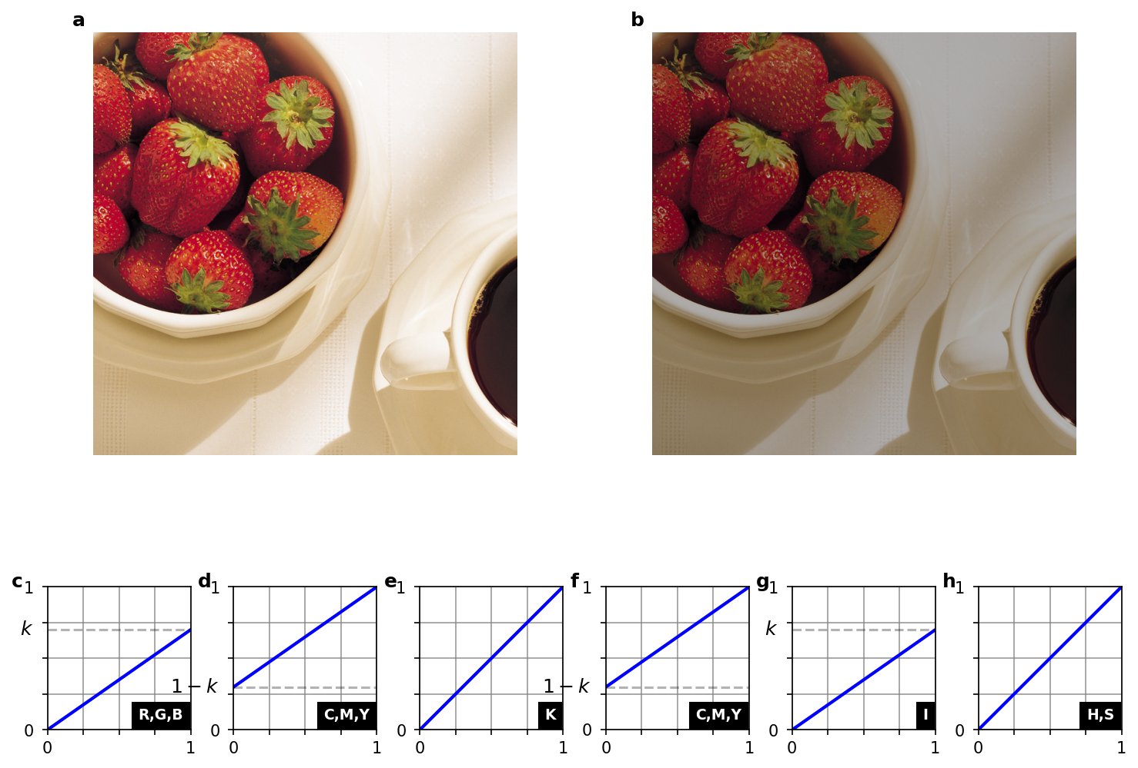

**Homework2: Implement Figure 6.31 by programming with Python**

**Python Code:**

**import** numpy as np

**import** imageio.v2 as imageio

**import** matplotlib.pyplot as plt

**import** os

**import** matplotlib.gridspec as gridspec

**def** rgb_complement(image):

**return** 255 **-** image

**def** rgb_to_hsi(rgb_image):

    img_float **=** rgb_image.astype(float) **/** 255.0

    R, G, B **=** img_float[:, :, 0], img_float[:, :, 1], img_float[:, :, 2]

    H **=** np.zeros_like(R)

    S **=** np.zeros_like(R)

    I **=** (R **+** G **+** B) **/** 3.0

    min_rgb **=** np.minimum(np.minimum(R, G), B)

    with warnings.catch_warnings():

        warnings.simplefilter("ignore", RuntimeWarning)

        S **=** 1 **-** (3.0 **/** (R **+** G **+** B **+** 1e**-**6)) **\*** min_rgb

    num **=** 0.5 **\*** ((R **-** G) **+** (R **-** B))

    den **=** np.sqrt((R **-** G) **\*\*** 2 **+** (R **-** B) **\*** (G **-** B))

    theta **=** np.arccos(np.clip(num **/** (den **+** 1e**-**6), **-**1, 1))

    theta **=** np.degrees(theta)

    H[B <**=** G] **=** theta[B <**=** G]

    H[B > G] **=** 360 **-** theta[B > G]

    H[S **==** 0] **=** 0

    hsi_image **=** np.stack([H, S, I], axis**=**2)

**return** hsi_image

**def** hsi_to_rgb(hsi_image):

    H, S, I **=** hsi_image[:, :, 0], hsi_image[:, :, 1], hsi_image[:, :, 2]

    R, G, B **=** np.zeros_like(H), np.zeros_like(H), np.zeros_like(H)

    idx **=** (H >**=** 0) & (H < 120)

    B[idx] **=** I[idx] **\*** (1 **-** S[idx])

    R[idx] **=** I[idx] **\*** (1 **+** (S[idx] **\*** np.cos(np.radians(H[idx]))) **/** np.cos(np.radians(60 **-** H[idx])))

    G[idx] **=** 3 **\*** I[idx] **-** (R[idx] **+** B[idx])

    idx **=** (H >**=** 120) & (H < 240)

    H_prime **=** H[idx] **-** 120

    R[idx] **=** I[idx] **\*** (1 **-** S[idx])

    G[idx] **=** I[idx] **\*** (1 **+** (S[idx] **\*** np.cos(np.radians(H_prime))) **/** np.cos(np.radians(60 **-** H_prime)))

    B[idx] **=** 3 **\*** I[idx] **-** (R[idx] **+** G[idx])

    idx **=** (H >**=** 240) & (H < 360)

    H_prime **=** H[idx] **-** 240

    G[idx] **=** I[idx] **\*** (1 **-** S[idx])

    B[idx] **=** I[idx] **\*** (1 **+** (S[idx] **\*** np.cos(np.radians(H_prime))) **/** np.cos(np.radians(60 **-** H_prime)))

    R[idx] **=** 3 **\*** I[idx] **-** (G[idx] **+** B[idx])

    rgb_image **=** np.stack([R, G, B], axis**=**2)

    rgb_image **=** np.clip(rgb_image **\*** 255, 0, 255).astype(np.uint8)

**return** rgb_image

**def** hsi_transform_from_book(image):

    hsi_img **=** rgb_to_hsi(image)

    H, S, I **=** hsi_img[:, :, 0], hsi_img[:, :, 1], hsi_img[:, :, 2]

    H_transformed **=** (H **+** 180) **%** 360

    S_transformed **=** S

    I_transformed **=** 1.0 **-** I

    hsi_transformed **=** np.stack([H_transformed, S_transformed, I_transformed], axis**=**2)

**return** hsi_to_rgb(hsi_transformed)

**def** plot_transform_functions(fig, spec):

    """

    Plots the four transformation functions

    """

    gs_nested **=** gridspec.GridSpecFromSubplotSpec(2, 2, subplot_spec**=**spec, wspace**=**0.1, hspace**=**0.1)

    x **=** np.linspace(0, 1, 100)

    plots_def **=** {

        '00': {'type': 'rgb', 'label': 'R,G,B'},

        '01': {'type': 'h', 'label': 'H'},

        '10': {'type': 's', 'label': 'S'},

        '11': {'type': 'i', 'label': 'I'}

    }

**for** i **in** range(2):

**for** j **in** range(2):

            ax **=** fig.add_subplot(gs_nested[i, j])

            key **=** f'{i}{j}'

            p_def **=** plots_def[key]

**if** p_def['type'] **==** 'rgb' **or** p_def['type'] **==** 'i':

                ax.plot([0, 1], [1, 0], 'k')

**elif** p_def['type'] **==** 'h':

                ax.plot([0, 0.5], [0.5, 1], 'k')

                ax.plot([0.5, 1], [0, 0.5], 'k')

**elif** p_def['type'] **==** 's':

                ax.plot([0, 1], [0, 1], 'k')

            ax.set_aspect('equal', adjustable**=**'box')

            ax.set_xlim(0, 1)

            ax.set_ylim(0, 1)

            ticks **=** np.linspace(0, 1, 6)

            ax.set_xticks(ticks)

            ax.set_yticks(ticks)

            ax.set_xticklabels(['0', '', '', '', '', '1'])

            ax.set_yticklabels(['0', '', '', '', '', '1'])

            ax.grid(True, color**=**'black', linewidth**=**0.75)

            ax.tick_params(length**=**0)

            ax.text(0.25, 0.15, p_def['label'], ha**=**'center', va**=**'center',

                    bbox**=**{'facecolor': 'darkgray', 'edgecolor': 'black', 'pad': 4})

**if** __name__ **==** "__main__":

    input_dir **=** "original_image"

    output_dir **=** "output_image"

    os.makedirs(output_dir, exist_ok**=**True)

    image_filename **=** "Fig0630(01)(strawberries_fullcolor).tif"

    image_path **=** os.path.join(input_dir, image_filename)

    original_image **=** imageio.imread(image_path)

    base_name **=** os.path.splitext(image_filename)[0]

    rgb_comp_image **=** rgb_complement(original_image)

    hsi_comp_image **=** hsi_transform_from_book(original_image)

    fig **=** plt.figure(figsize**=**(10, 10))

    fig.suptitle(f'Color Complement Transformations (Fig 6.31) - {image_filename}', fontsize**=**16)

    gs_main **=** gridspec.GridSpec(2, 2, figure**=**fig, wspace**=**0.05, hspace**=**0.15)

    ax_a **=** fig.add_subplot(gs_main[0, 0])

    ax_a.imshow(original_image)

    ax_a.set_title('a) Original Image')

    ax_a.axis('off')

    plot_transform_functions(fig, gs_main[0, 1])

    ax_b_title **=** fig.add_subplot(gs_main[0, 1])

    ax_b_title.set_title('b) Transformation Functions')

    ax_b_title.axis('off')

    ax_c **=** fig.add_subplot(gs_main[1, 0])

    ax_c.imshow(rgb_comp_image)

    ax_c.set_title('c) RGB Complement')

    ax_c.axis('off')

    ax_d **=** fig.add_subplot(gs_main[1, 1])

    ax_d.imshow(hsi_comp_image)

    ax_d.set_title('d) HSI-based Complement')

    ax_d.axis('off')

    combined_output_path **=** os.path.join(output_dir, f"{base_name}_complement_full_figure.png")

    plt.savefig(combined_output_path, bbox_inches**=**'tight')

    plt.close()

**Processed Images:**

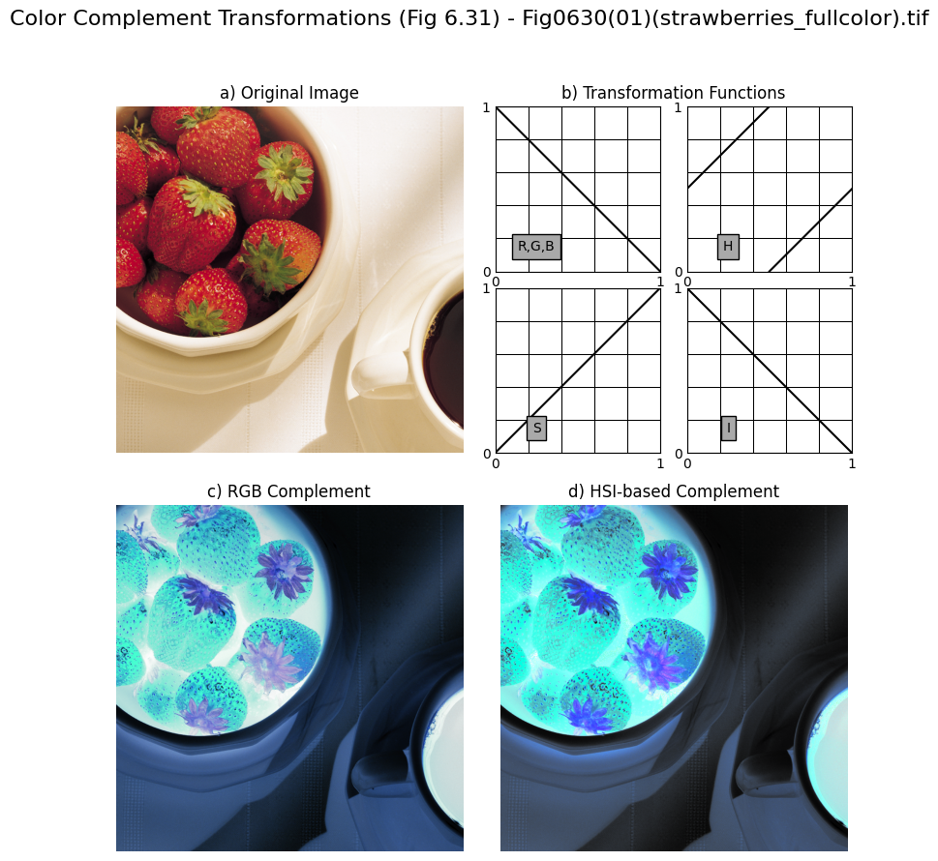

**Homework3: Implement Figure 6.31 by programming with Python**

**Python Code:**

**import** numpy as np

**import** imageio.v2 as imageio

**import** matplotlib.pyplot as plt

**import** os

**def** color_slicing_cube(image, center_color, width, neutral_color**=**(0.5, 0.5, 0.5)):

    img_float **=** image.astype(np.float64) **/** 255.0

    center **=** np.array(center_color)

    diff **=** np.abs(img_float **-** center)

    mask **=** np.any(diff > width **/** 2.0, axis**=**2)

    result_image **=** np.copy(image)

    neutral_pixel **=** (np.array(neutral_color) **\*** 255).astype(np.uint8)

    result_image[mask] **=** neutral_pixel

**return** result_image

**def** color_slicing_sphere(image, center_color, radius, neutral_color**=**(0.5, 0.5, 0.5)):

    img_float **=** image.astype(np.float64) **/** 255.0

    center **=** np.array(center_color)

    distances_sq **=** np.sum((img_float **-** center) **\*\*** 2, axis**=**2)

    mask **=** distances_sq > radius **\*\*** 2

    result_image **=** np.copy(image)

    neutral_pixel **=** (np.array(neutral_color) **\*** 255).astype(np.uint8)

    result_image[mask] **=** neutral_pixel

**return** result_image

**if** __name__ **==** "__main__":

    input_dir **=** "original_image"

    output_dir **=** "output_image"

    os.makedirs(output_dir, exist_ok**=**True)

    image_filename **=** "Fig0630(01)(strawberries_fullcolor).tif"

    image_path **=** os.path.join(input_dir, image_filename)

    original_image **=** imageio.imread(image_path)

    base_name **=** os.path.splitext(image_filename)[0]

    center_color_a **=** (0.6863, 0.1608, 0.1922)

    width_W **=** 0.2549

    radius_R0 **=** 0.1765

    cube_sliced_image **=** color_slicing_cube(original_image, center_color_a, width_W)

    sphere_sliced_image **=** color_slicing_sphere(original_image, center_color_a, radius_R0)

    fig, axes **=** plt.subplots(1, 2, figsize**=**(12, 6))

    fig.suptitle(f'Color Slicing (Fig 6.32) - {image_filename}', fontsize**=**16)

    axes[0].imshow(cube_sliced_image)

    axes[0].set_title(f'a) Cube transform, $W={width_W}$')

    axes[0].axis('off')

    axes[1].imshow(sphere_sliced_image)

    axes[1].set_title(f'b) Sphere transform, $R_0={radius_R0}$')

    axes[1].axis('off')

    plt.tight_layout(rect**=**[0, 0.03, 1, 0.95])

    combined_output_path **=** os.path.join(output_dir, f"{base_name}_color_slicing_results.png")

    plt.savefig(combined_output_path, bbox_inches**=**'tight')

    plt.close()

**Processed Images:**

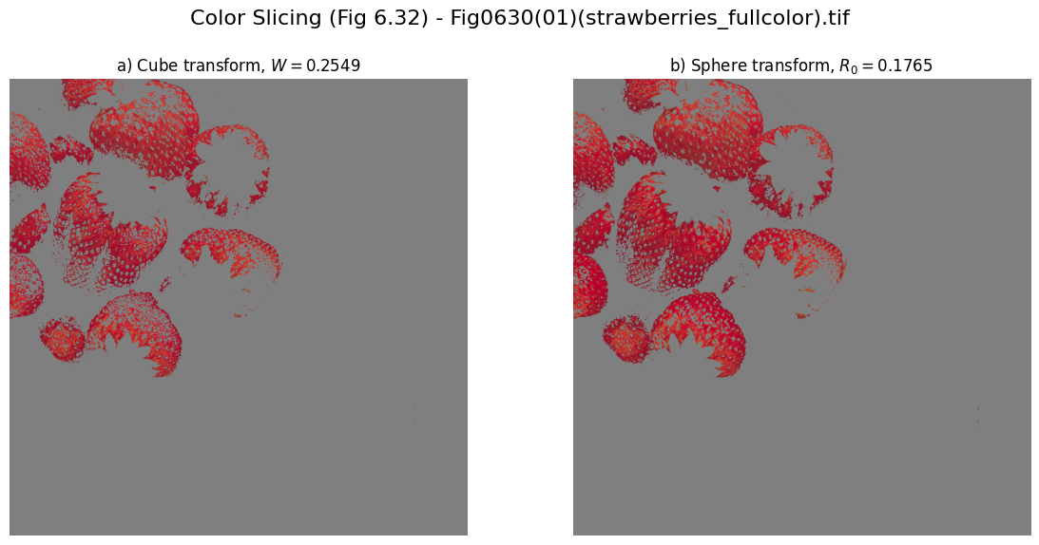

**Homework4: Implement Figure 6.33 by programming with Python**

**Python Code:**

**import** numpy as np

**import** imageio.v2 as imageio

**import** matplotlib.pyplot as plt

**import** os

**def** tone_correction(image, contrast, midpoint):

    img_float **=** image.astype(np.float64) **/** 255.0

    epsilon **=** 1e**-**6

    corrected_float **=** 1 **/** (1 **+** (midpoint **/** (img_float **+** epsilon)) **\*\*** contrast)

    corrected_image **=** np.clip(corrected_float **\*** 255, 0, 255).astype(np.uint8)

**return** corrected_image

**def** plot_tone_curve(ax, contrast, midpoint):

    r **=** np.linspace(0, 1, 256)

    epsilon **=** 1e**-**6

    s **=** 1 **/** (1 **+** (midpoint **/** (r **+** epsilon)) **\*\*** contrast)

    ax.plot(r, s, 'k')

    ax.set_aspect('equal', adjustable**=**'box')

    ax.set_xlim(0, 1)

    ax.set_ylim(0, 1)

    ticks **=** np.linspace(0, 1, 5)  # For 4 squares

    ax.set_xticks(ticks)

    ax.set_yticks(ticks)

    ax.set_xticklabels(['0', '', '', '', '1'])

    ax.set_yticklabels(['0', '', '', '', '1'])

    ax.grid(True, color**=**'black', linewidth**=**0.75)

    ax.tick_params(length**=**0)  # Remove tick marks

    ax.text(0.5, 0.2, 'R,G,B', ha**=**'center', va**=**'center',

            bbox**=**{'facecolor': 'white', 'edgecolor': 'black', 'pad': 4})

**if** __name__ **==** "__main__":

    input_dir **=** "original_image"

    output_dir **=** "output_image"

    os.makedirs(output_dir, exist_ok**=**True)

    image_filename **=** "Fig0635(top_ left_flower).tif"

    image_path **=** os.path.join(input_dir, image_filename)

    original_image **=** imageio.imread(image_path)

    base_name **=** os.path.splitext(image_filename)[0]

    contrast_E **=** 10

    midpoint_m **=** 0.5

    corrected_image **=** tone_correction(original_image, contrast_E, midpoint_m)

    fig **=** plt.figure(figsize**=**(18, 7))

    gs **=** fig.add_gridspec(1, 3, width_ratios**=**[4, 4, 1.5], wspace**=**0.05)

    fig.suptitle(f'Tone Correction (Fig 6.33) - {image_filename}', fontsize**=**16)

    ax0 **=** fig.add_subplot(gs[0])

    ax0.imshow(original_image)

    ax0.set_title('a) Flat Image')

    ax0.axis('off')

    ax1 **=** fig.add_subplot(gs[1])

    ax1.imshow(corrected_image)

    ax1.set_title('b) Corrected Image')

    ax1.axis('off')

    ax2 **=** fig.add_subplot(gs[2])

    plot_tone_curve(ax2, contrast_E, midpoint_m)

    ax2.set_title('c) Transformation')

    plt.tight_layout(rect**=**[0, 0.03, 1, 0.95])

    combined_output_path **=** os.path.join(output_dir, f"{base_name}_tone_correction_results.png")

    plt.savefig(combined_output_path, bbox_inches**=**'tight')

    plt.close()

**Processed Images:**

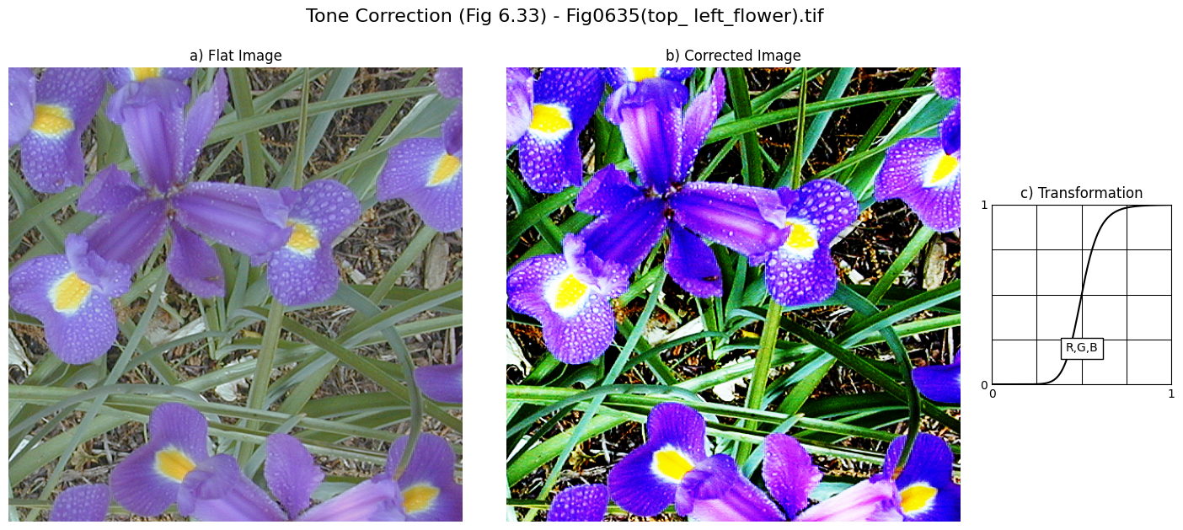

**Homework5: Implement Figure 6.35 by programming with Python**

**Python Code:**

**import** numpy as np

**import** imageio.v2 as imageio

**import** matplotlib.pyplot as plt

**import** os

**import** warnings

**import** matplotlib.gridspec as gridspec

**def** rgb_to_hsi(rgb_image):

    img_float **=** rgb_image.astype(float) **/** 255.0

    R, G, B **=** img_float[:, :, 0], img_float[:, :, 1], img_float[:, :, 2]

    H **=** np.zeros_like(R)

    S **=** np.zeros_like(R)

    I **=** (R **+** G **+** B) **/** 3.0

    min_rgb **=** np.minimum(np.minimum(R, G), B)

    with warnings.catch_warnings():

        warnings.simplefilter("ignore", RuntimeWarning)

        S **=** 1 **-** (3.0 **/** (R **+** G **+** B **+** 1e**-**6)) **\*** min_rgb

    num **=** 0.5 **\*** ((R **-** G) **+** (R **-** B))

    den **=** np.sqrt((R **-** G) **\*\*** 2 **+** (R **-** B) **\*** (G **-** B))

    with warnings.catch_warnings():

        warnings.simplefilter("ignore", RuntimeWarning)

        theta **=** np.arccos(np.clip(num **/** (den **+** 1e**-**6), **-**1, 1))

    theta **=** np.degrees(theta)

    H[B <**=** G] **=** theta[B <**=** G]

    H[B > G] **=** 360 **-** theta[B > G]

    H[S **==** 0] **=** 0

    hsi_image **=** np.stack([H, S, I], axis**=**2)

**return** hsi_image

**def** hsi_to_rgb(hsi_image):

    H, S, I **=** hsi_image[:, :, 0], hsi_image[:, :, 1], hsi_image[:, :, 2]

    R, G, B **=** np.zeros_like(H), np.zeros_like(H), np.zeros_like(H)

    idx **=** (H >**=** 0) & (H < 120)

    B[idx] **=** I[idx] **\*** (1 **-** S[idx])

    R[idx] **=** I[idx] **\*** (1 **+** (S[idx] **\*** np.cos(np.radians(H[idx]))) **/** np.cos(np.radians(60 **-** H[idx])))

    G[idx] **=** 3 **\*** I[idx] **-** (R[idx] **+** B[idx])

    idx **=** (H >**=** 120) & (H < 240)

    H_prime **=** H[idx] **-** 120

    R[idx] **=** I[idx] **\*** (1 **-** S[idx])

    G[idx] **=** I[idx] **\*** (1 **+** (S[idx] **\*** np.cos(np.radians(H_prime))) **/** np.cos(np.radians(60 **-** H_prime)))

    B[idx] **=** 3 **\*** I[idx] **-** (R[idx] **+** G[idx])

    idx **=** (H >**=** 240) & (H < 360)

    H_prime **=** H[idx] **-** 240

    G[idx] **=** I[idx] **\*** (1 **-** S[idx])

    B[idx] **=** I[idx] **\*** (1 **+** (S[idx] **\*** np.cos(np.radians(H_prime))) **/** np.cos(np.radians(60 **-** H_prime)))

    R[idx] **=** 3 **\*** I[idx] **-** (G[idx] **+** B[idx])

    rgb_image **=** np.stack([R, G, B], axis**=**2)

    rgb_image **=** np.clip(rgb_image **\*** 255, 0, 255).astype(np.uint8)

**return** rgb_image

**def** histogram_equalization(intensity_channel):

    I_uint8 **=** np.clip(intensity_channel **\*** 255, 0, 255).astype(np.uint8)

    hist, _ **=** np.histogram(I_uint8.flatten(), 256, [0, 256])

    cdf **=** hist.cumsum()

    cdf_m **=** np.ma.masked_equal(cdf, 0)

    cdf_m **=** (cdf_m **-** cdf_m.min()) **\*** 255 **/** (cdf_m.max() **-** cdf_m.min())

    cdf **=** np.ma.filled(cdf_m, 0).astype('uint8')

    equalized_I_uint8 **=** cdf[I_uint8]

    equalized_I_float **=** equalized_I_uint8.astype(float) **/** 255.0

    equalized_hist, _ **=** np.histogram(equalized_I_uint8.flatten(), 256, [0, 256])

    transform_func **=** cdf **/** 255.0

**return** equalized_I_float, hist, equalized_hist, transform_func

**def** plot_panel_b(fig, spec, hist_orig, hist_eq, transform_func, median_orig, median_eq):

    gs_nested **=** gridspec.GridSpecFromSubplotSpec(2, 2, subplot_spec**=**spec, wspace**=**0.2, hspace**=**0.2)

**def** style_ax(ax):

        ax.set_aspect('equal', adjustable**=**'box')

        ax.set_xlim(0, 1)

        ax.set_ylim(0, 1)

        ticks **=** np.linspace(0, 1, 5)

        ax.set_xticks(ticks)

        ax.set_yticks(ticks)

        ax.set_xticklabels(['0', '', '', '', '1'])

        ax.set_yticklabels(['0', '', '', '', '1'])

        ax.grid(True, color**=**'black', linewidth**=**0.75)

        ax.tick_params(length**=**0)

    ax_h **=** fig.add_subplot(gs_nested[0, 0])

    ax_h.plot([0, 1], [0, 1], 'k')

    ax_h.text(0.5, 0.5, 'H', ha**=**'center', va**=**'center', bbox**=**{'facecolor': 'white', 'edgecolor': 'black'})

    style_ax(ax_h)

    ax_s **=** fig.add_subplot(gs_nested[0, 1])

    ax_s.plot([0, 1], [0, 1], 'k')

    ax_s.text(0.5, 0.5, 'S', ha**=**'center', va**=**'center', bbox**=**{'facecolor': 'white', 'edgecolor': 'black'})

    style_ax(ax_s)

    ax_i **=** fig.add_subplot(gs_nested[1, 0])

    r **=** np.linspace(0, 1, 256)

    ax_i.plot(r, transform_func, 'k')

    ax_i.plot([median_orig, median_orig], [0, median_eq], 'k--')

    ax_i.plot([0, median_orig], [median_eq, median_eq], 'k--')

    ax_i.text(0.5, 0.5, 'I', ha**=**'center', va**=**'center', bbox**=**{'facecolor': 'white', 'edgecolor': 'black'})

    style_ax(ax_i)

    # Specific labels for I plot

    ax_i.set_xticklabels(['0', '', '', '', '1'])

    ax_i.set_yticklabels(['0', '', '', '', '1'])

    ax_i.set_xlabel(f'{median_orig:.2f}', labelpad**=-**10)

    ax_i.set_ylabel(f'{median_eq:.2f}', labelpad**=-**10, rotation**=**0, ha**=**'right')

    gs_hist **=** gridspec.GridSpecFromSubplotSpec(2, 1, subplot_spec**=**gs_nested[1, 1], hspace**=**0.1)

    ax_hist1 **=** fig.add_subplot(gs_hist[0])

    ax_hist2 **=** fig.add_subplot(gs_hist[1])

    ax_hist1.bar(range(256), hist_orig, color**=**'black', width**=**1.0)

    ax_hist1.set_title(f'Before (median={median_orig:.2f})', fontsize**=**8)

    ax_hist2.bar(range(256), hist_eq, color**=**'black', width**=**1.0)

    ax_hist2.set_title(f'After (median={median_eq:.2f})', fontsize**=**8)

**for** ax **in** [ax_hist1, ax_hist2]:

        ax.set_yticks([])

        ax.set_xticks([])

        ax.set_xlim(0, 255)

**if** __name__ **==** "__main__":

    input_dir **=** "original_image"

    output_dir **=** "output_image"

    os.makedirs(output_dir, exist_ok**=**True)

    image_filename **=** "Fig0637(a)(caster_stand_original).tif"

    image_path **=** os.path.join(input_dir, image_filename)

    original_image **=** imageio.imread(image_path)

    base_name **=** os.path.splitext(image_filename)[0]

    hsi_orig **=** rgb_to_hsi(original_image)

    H_orig, S_orig, I_orig **=** hsi_orig[:, :, 0], hsi_orig[:, :, 1], hsi_orig[:, :, 2]

    I_eq, hist_orig, hist_eq, transform_func **=** histogram_equalization(I_orig)

    hsi_c **=** np.stack([H_orig, S_orig, I_eq], axis**=**2)

    image_c **=** hsi_to_rgb(hsi_c)

    S_d_pre **=** S_orig **\*\*** 0.75

    I_d_pre **=** I_orig **\*\*** 0.75

    I_d_eq, _, _, _ **=** histogram_equalization(I_d_pre)

    hsi_d **=** np.stack([H_orig, S_d_pre, I_d_eq], axis**=**2)

    image_d **=** hsi_to_rgb(hsi_d)

    fig **=** plt.figure(figsize**=**(10, 10))

    gs_main **=** gridspec.GridSpec(2, 2, figure**=**fig, wspace**=**0.05, hspace**=**0.3)

    fig.suptitle(f'HSI Histogram Equalization (Fig 6.35) - {image_filename}', fontsize**=**16)

    ax_a **=** fig.add_subplot(gs_main[0, 0])

    ax_a.imshow(original_image)

    ax_a.set_title('a) Original Image')

    ax_a.axis('off')

    median_orig **=** np.median(I_orig)

    median_eq **=** np.median(I_eq)

    plot_panel_b(fig, gs_main[0, 1], hist_orig, hist_eq, transform_func, median_orig, median_eq)

    ax_b_title **=** fig.add_subplot(gs_main[0, 1])

    ax_b_title.set_title('b) Transformations and Histograms')

    ax_b_title.axis('off')

    ax_c **=** fig.add_subplot(gs_main[1, 0])

    ax_c.imshow(image_c)

    ax_c.set_title('c) Intensity Equalized')

    ax_c.axis('off')

    ax_d **=** fig.add_subplot(gs_main[1, 1])

    ax_d.imshow(image_d)

    ax_d.set_title('d) Sat. & Int. Adjusted, then Int. Equalized')

    ax_d.axis('off')

    plt.tight_layout(rect**=**[0, 0.03, 1, 0.95])

    combined_output_path **=** os.path.join(output_dir, f"{base_name}_hsi_equalization_results.png")

    plt.savefig(combined_output_path, bbox_inches**=**'tight')

    plt.close()

**Processed Images:**

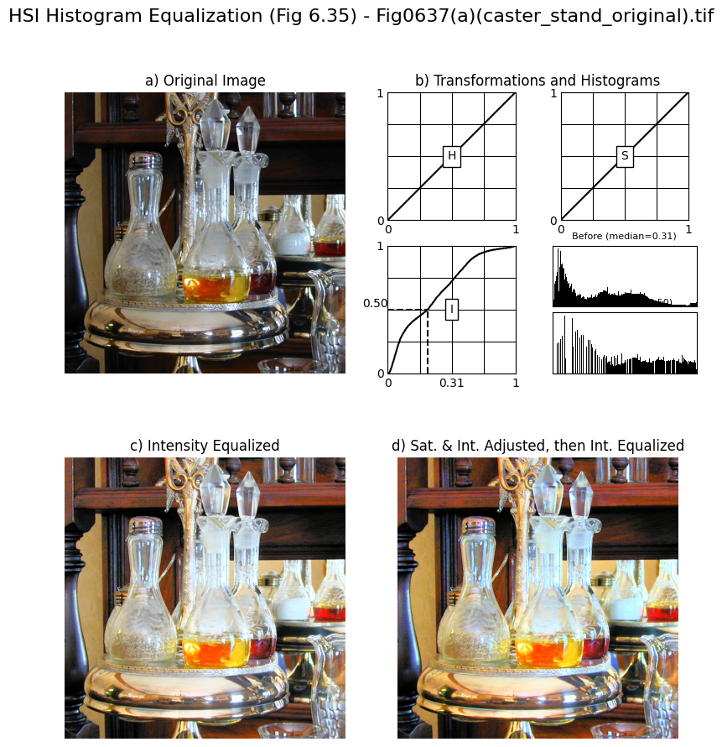

**Homework6: Implement Figure 6.44 by programming with Python**

**Python Code:**

**import** numpy as np

**import** imageio.v2 as imageio

**import** matplotlib.pyplot as plt

**import** os

**from** scipy **import** ndimage

**def** vector_gradient(image):

    img_float **=** image.astype(np.float64)

    g_xx **=** np.zeros_like(img_float[:, :, 0])

    g_yy **=** np.zeros_like(img_float[:, :, 0])

**for** i **in** range(3):

        channel **=** img_float[:, :, i]

        g_x **=** ndimage.sobel(channel, axis**=**1)

        g_y **=** ndimage.sobel(channel, axis**=**0)

        g_xx **+=** g_x **\*\*** 2

        g_yy **+=** g_y **\*\*** 2

    M **=** np.sqrt(g_xx **+** g_yy)

**return** M

**def** sum_of_gradients(image):

    img_float **=** image.astype(np.float64)

    M_sum **=** np.zeros_like(img_float[:, :, 0])

**for** i **in** range(3):

        channel **=** img_float[:, :, i]

        g_x **=** ndimage.sobel(channel, axis**=**1)

        g_y **=** ndimage.sobel(channel, axis**=**0)

        M_sum **+=** np.sqrt(g_x **\*\*** 2 **+** g_y **\*\*** 2)

**return** M_sum

**def** scale_to_uint8(image_float):

    max_val **=** np.max(image_float)

**if** max_val > 0:

        scaled_image **=** (image_float **/** max_val) **\*** 255

**else**:

        scaled_image **=** image_float

**return** scaled_image.astype(np.uint8)

**if** __name__ **==** "__main__":

    input_dir **=** "original_image"

    output_dir **=** "output_image"

    os.makedirs(output_dir, exist_ok**=**True)

    image_filename **=** "Fig0646(a)(lenna_original_RGB).tif"

    image_path **=** os.path.join(input_dir, image_filename)

    original_image **=** imageio.imread(image_path)

    base_name **=** os.path.splitext(image_filename)[0]

    grad_vector **=** vector_gradient(original_image)

    grad_sum **=** sum_of_gradients(original_image)

    grad_diff **=** np.abs(grad_vector **-** grad_sum)

    display_vector **=** scale_to_uint8(grad_vector)

    display_sum **=** scale_to_uint8(grad_sum)

    display_diff **=** scale_to_uint8(grad_diff)

    fig, axes **=** plt.subplots(2, 2, figsize**=**(10, 10))

    fig.suptitle(f'RGB Edge Detection (Fig 6.44) - {image_filename}', fontsize**=**16)

    axes[0, 0].imshow(original_image)

    axes[0, 0].set_title('a) Original RGB Image')

    axes[0, 1].imshow(display_vector, cmap**=**'gray')

    axes[0, 1].set_title('b) Vector Gradient')

    axes[1, 0].imshow(display_sum, cmap**=**'gray')

    axes[1, 0].set_title('c) Sum of Individual Gradients')

    axes[1, 1].imshow(display_diff, cmap**=**'gray')

    axes[1, 1].set_title('d) Difference (b) - (c)')

**for** ax **in** axes.flat:

        ax.axis('off')

    plt.tight_layout(rect**=**[0, 0.03, 1, 0.95])

    combined_output_path **=** os.path.join(output_dir, f"{base_name}_rgb_edge_detection_results.png")

    plt.savefig(combined_output_path, bbox_inches**=**'tight')

    plt.close()

**Processed Images:**

